**Create a S3 bucket, with no public access and upload files to the bucket & view the logs for the uploaded files.**

1. Created a S3 bucket with name - **h-aris3bucket** and**h-aris3bucket-logs** for viewing the logs.

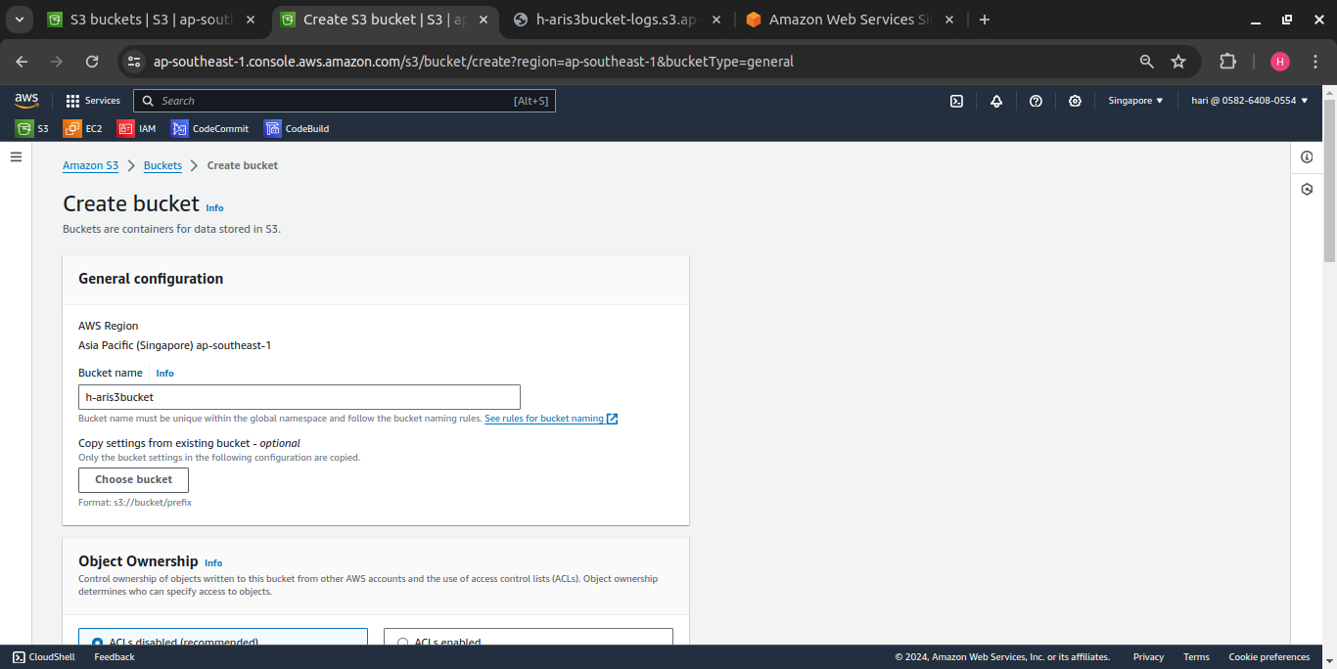

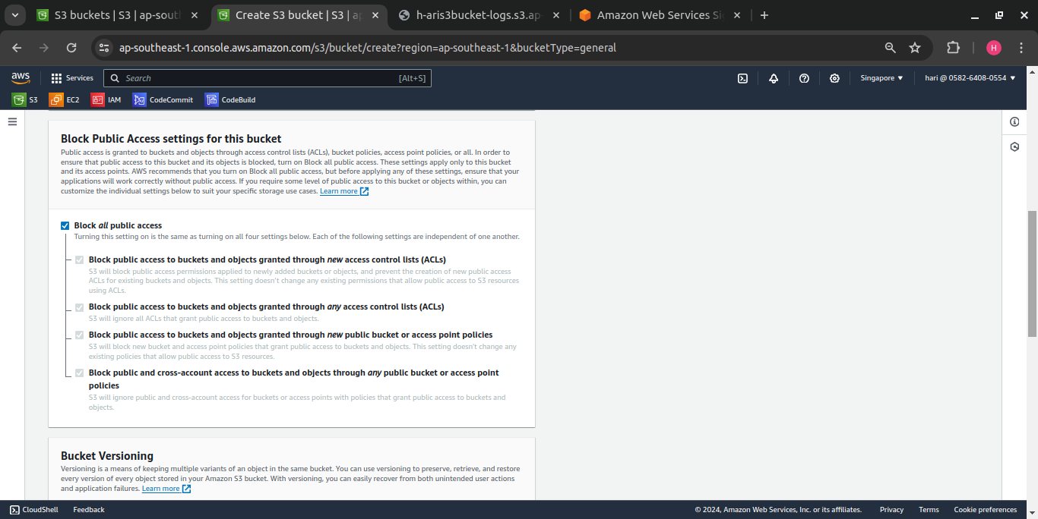

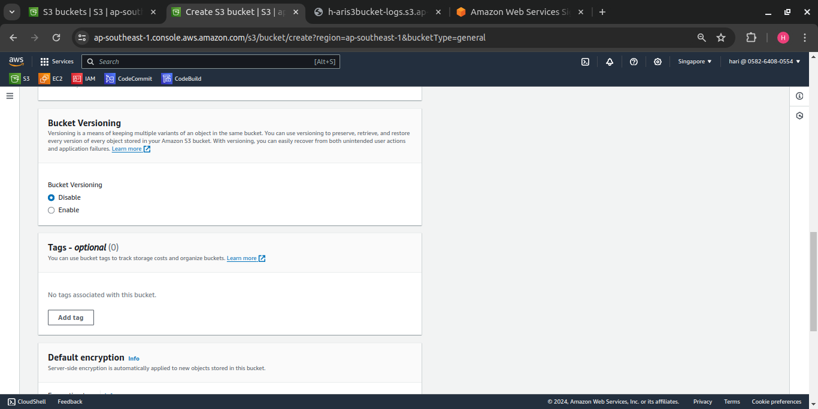

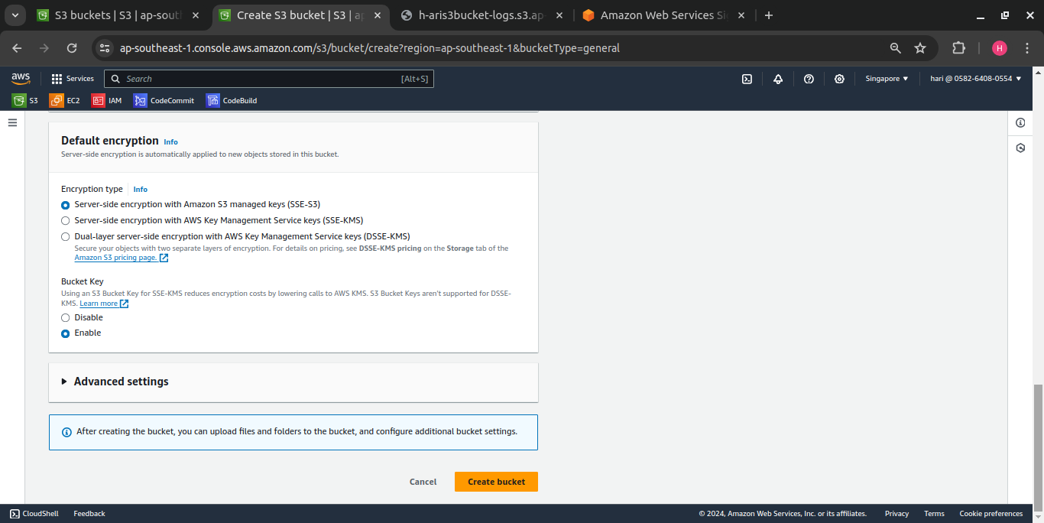

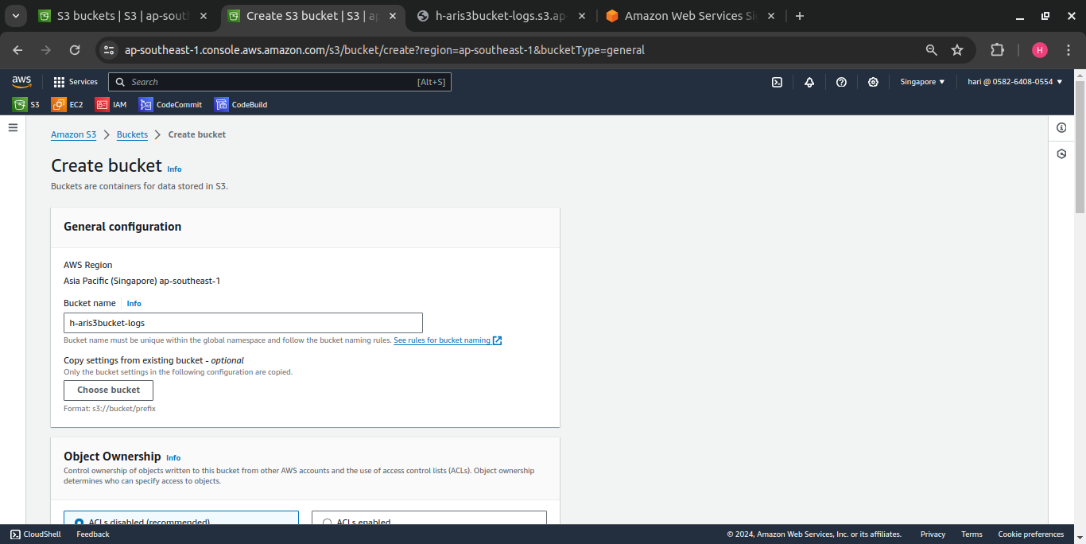

2 buckets are listed below,

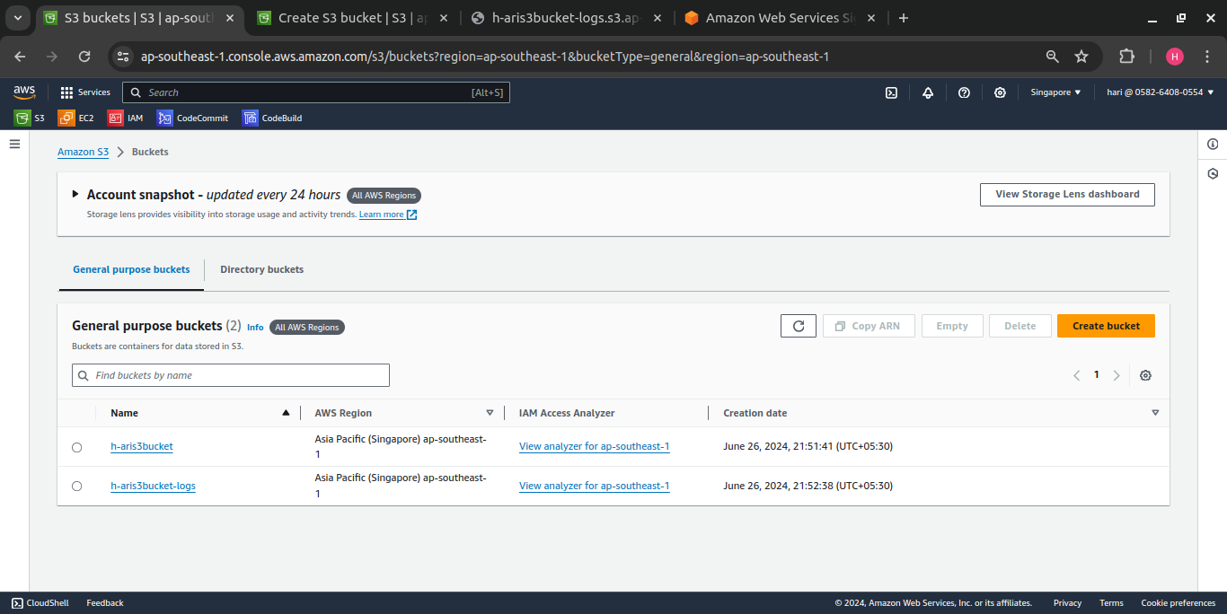

2. Enabling server access logging by adding the bucket – **h-aris3bucket-logs with h-aris3bucket** to **access the logs of the uploaded files in h-aris3bucket**

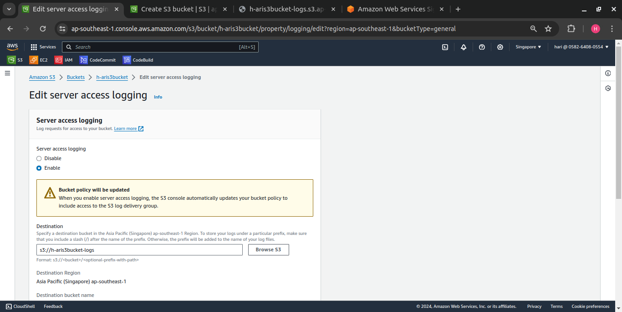

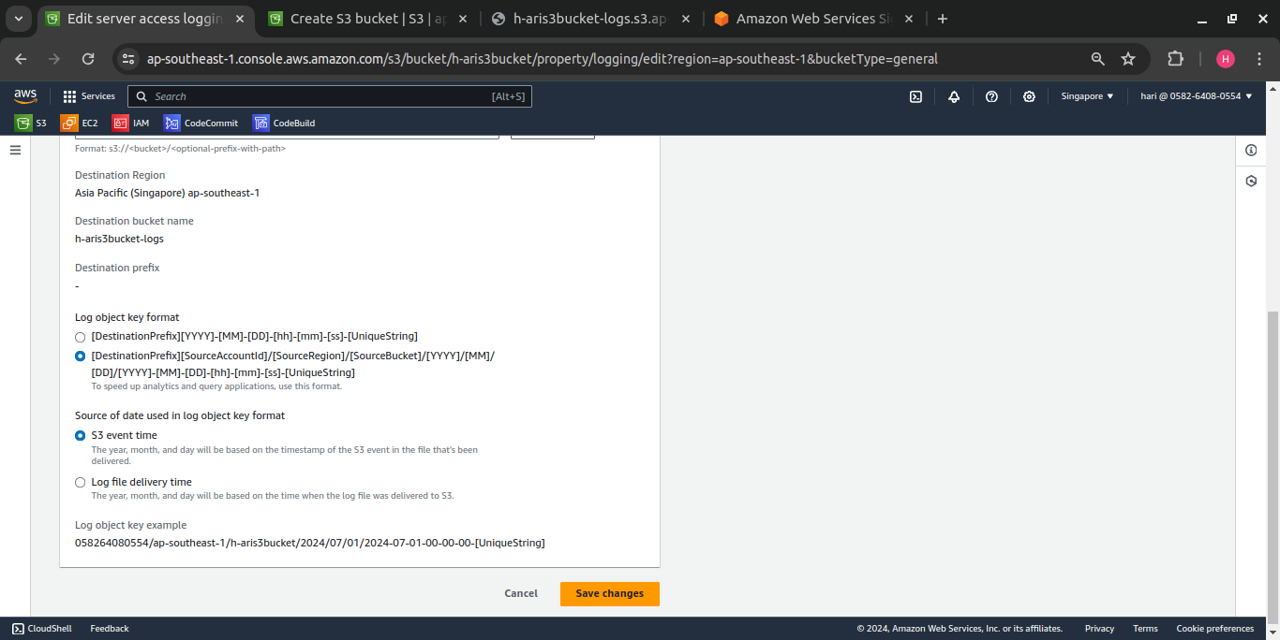

3. Uploaded 2 demo files to **h-aris3bucket,**

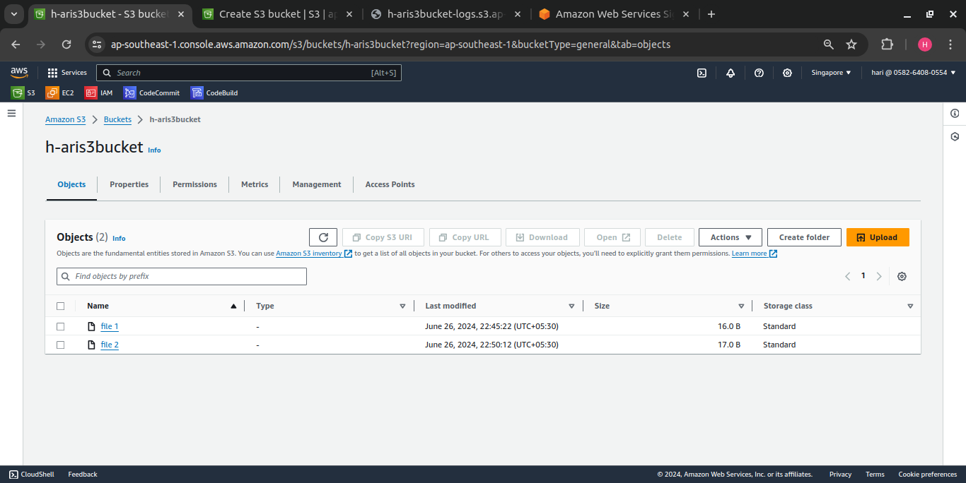

4. **h-aris3bucket-logs** bucket shows/lists the logs of the uploaded file,

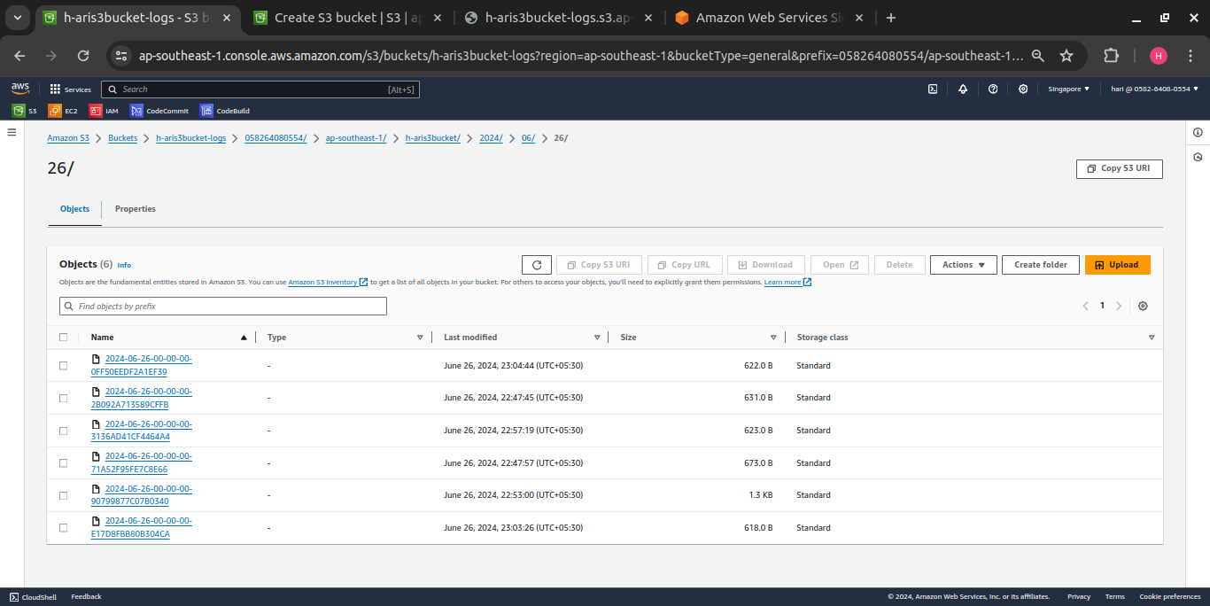

5. Opened one of the log in the browser,

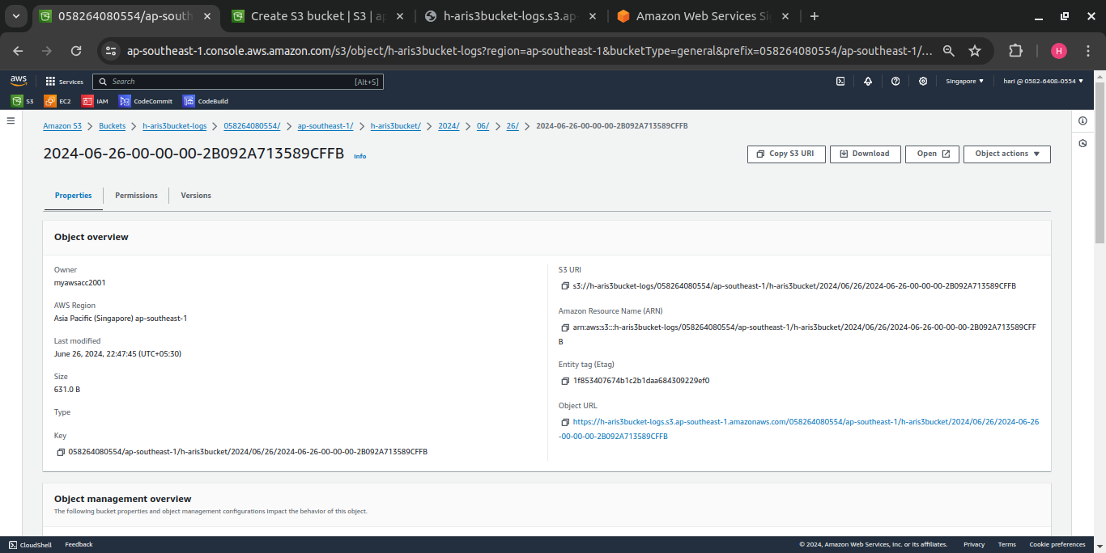

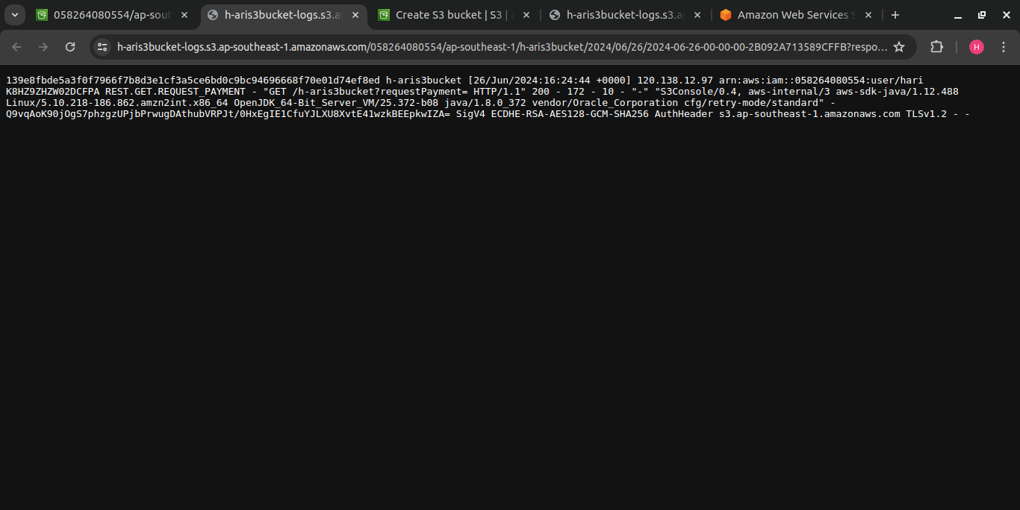

**Launch two ec2-instances and connect it to a application load balancer, where the output traffic from the server must be an load balancer IP address**

1. Created an EC2 instance with name **Apache-server** and updated number of instances as **2**.

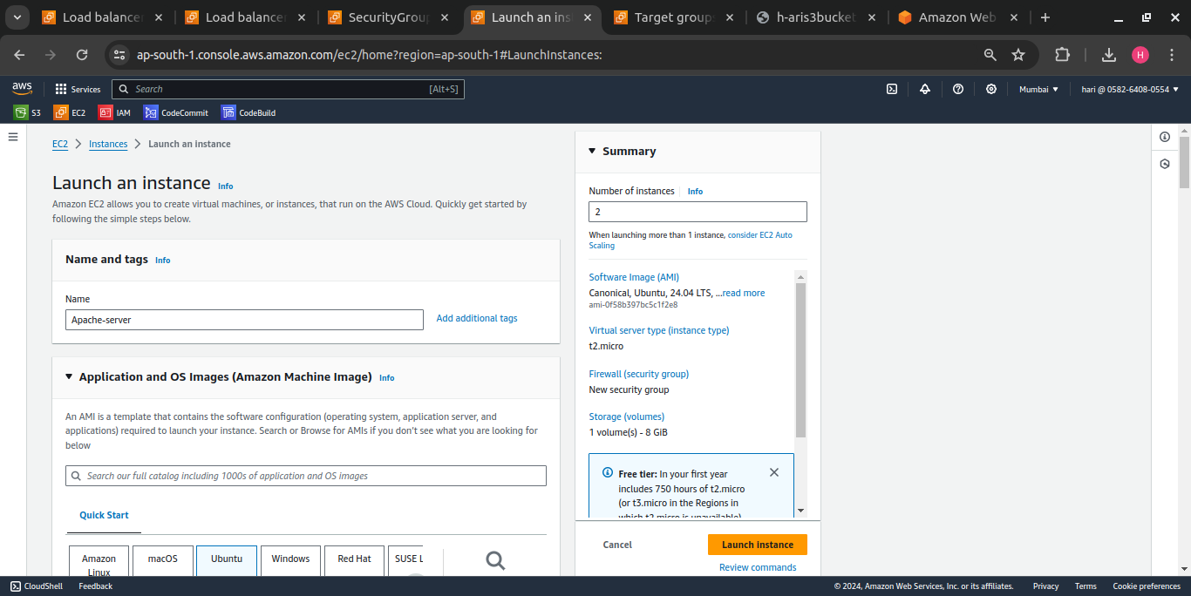

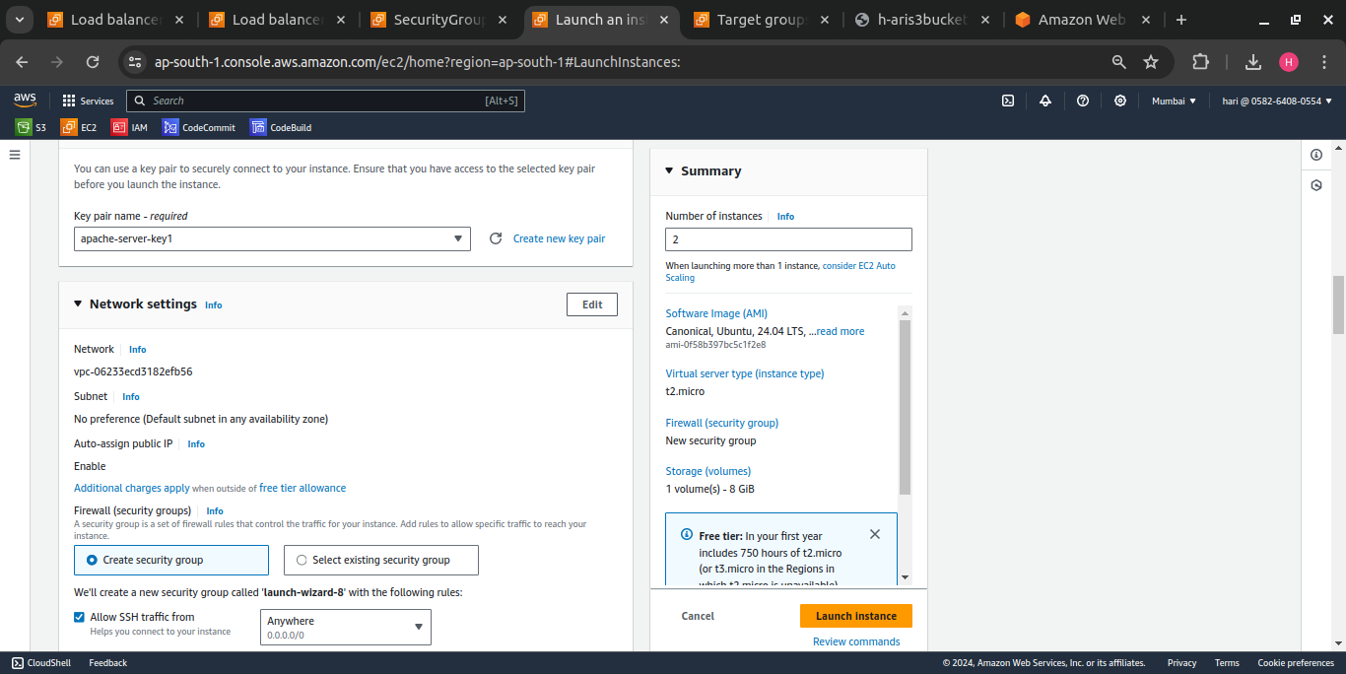

2. Updated user data column with commands to install an application – apache server

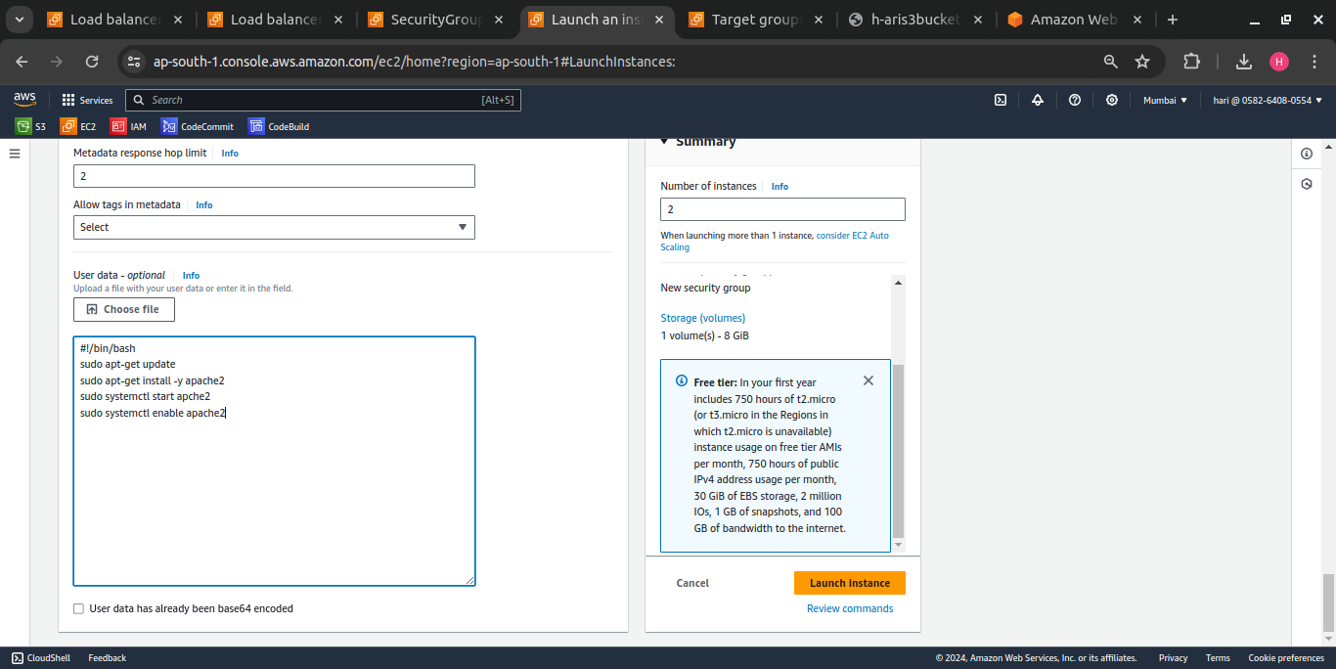

3. Created and running 2 EC2 instances,

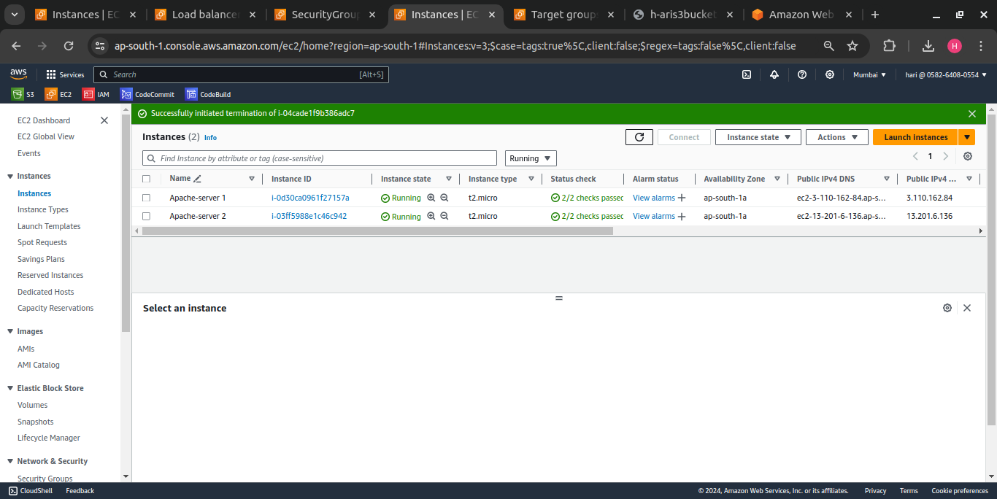

4. Connected to Apache-server 1

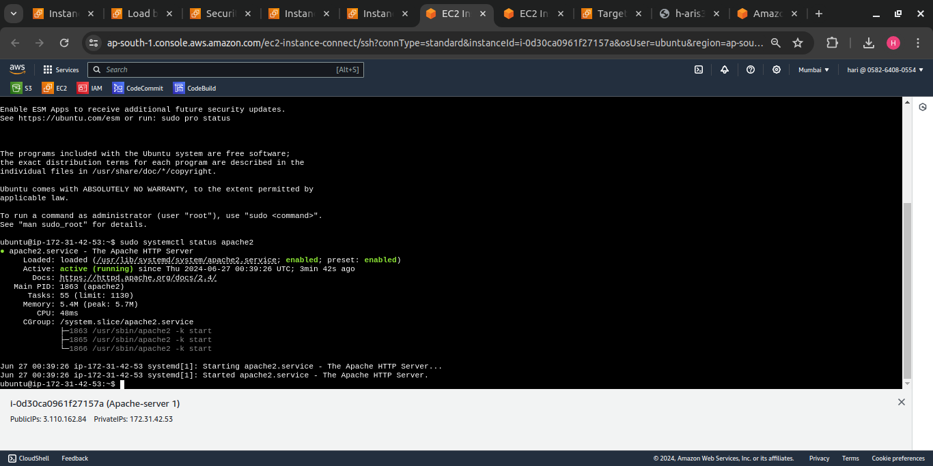

5. Connected to the server with public IP address: **3.110.162.84**

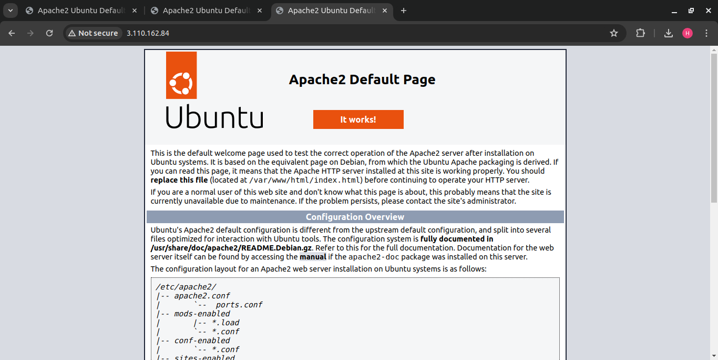

6. Connected to Apache-server 2

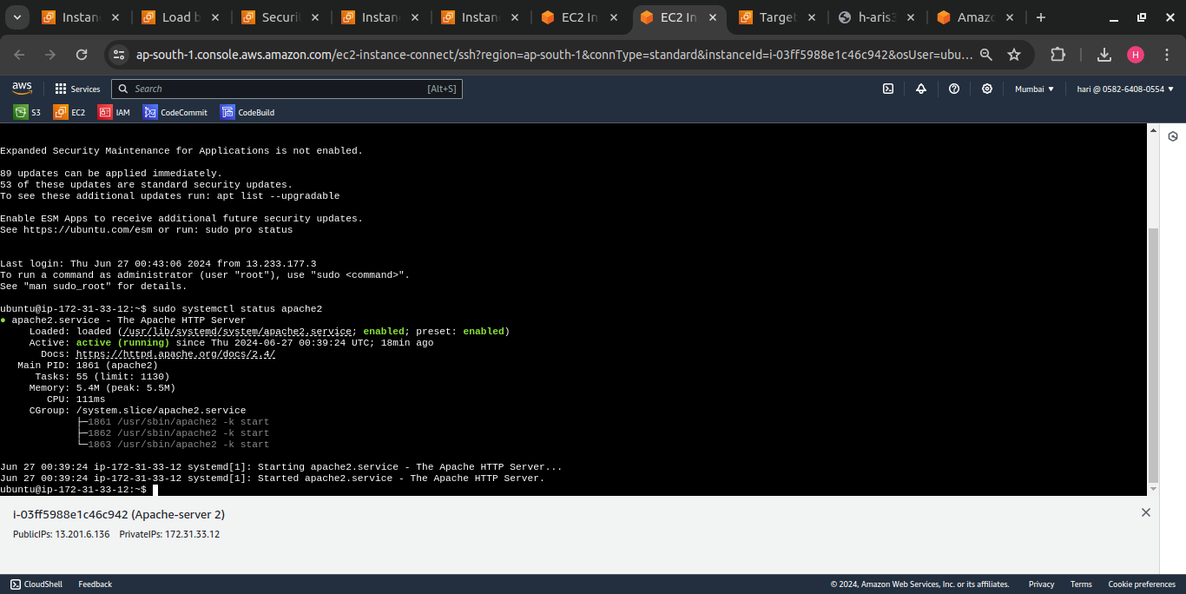

7. Connected to the server with public IP address: **13.201.6.136**

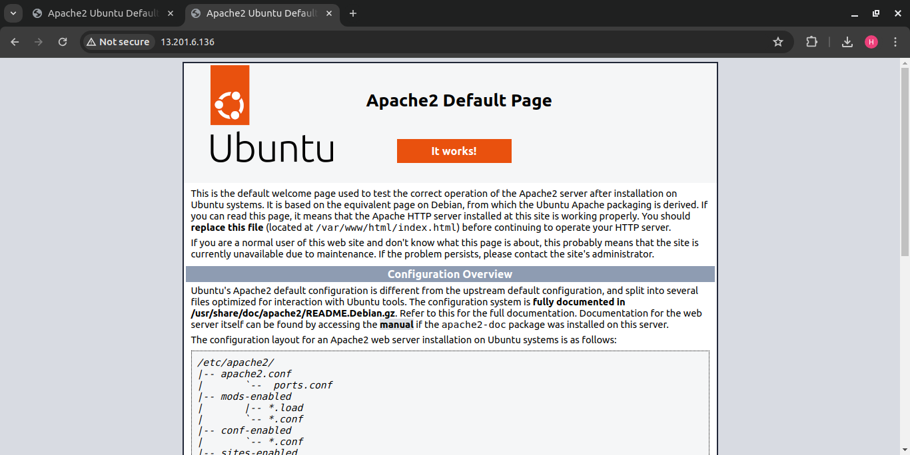

**8. Creating Application Load balancer**

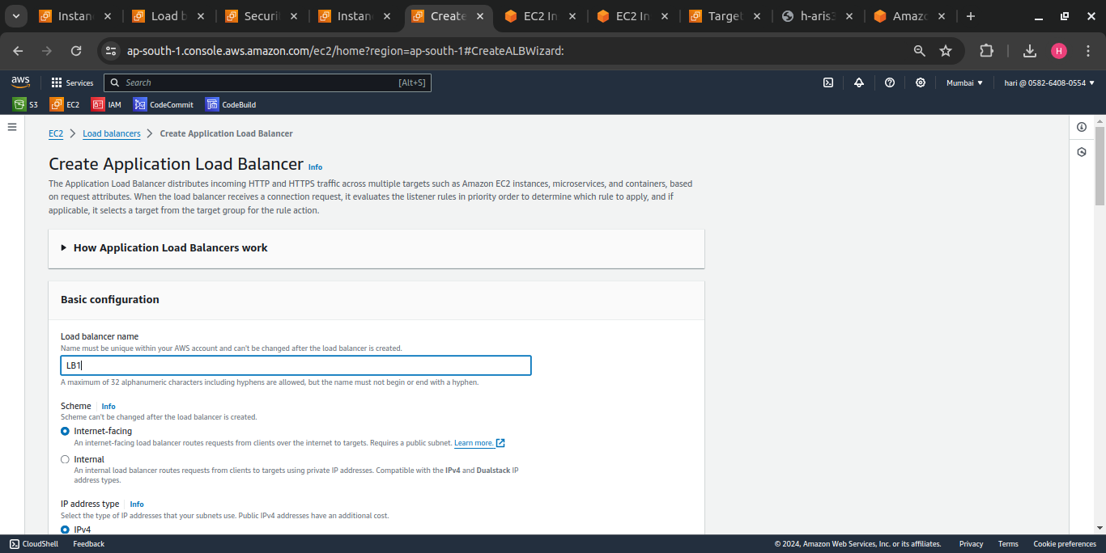

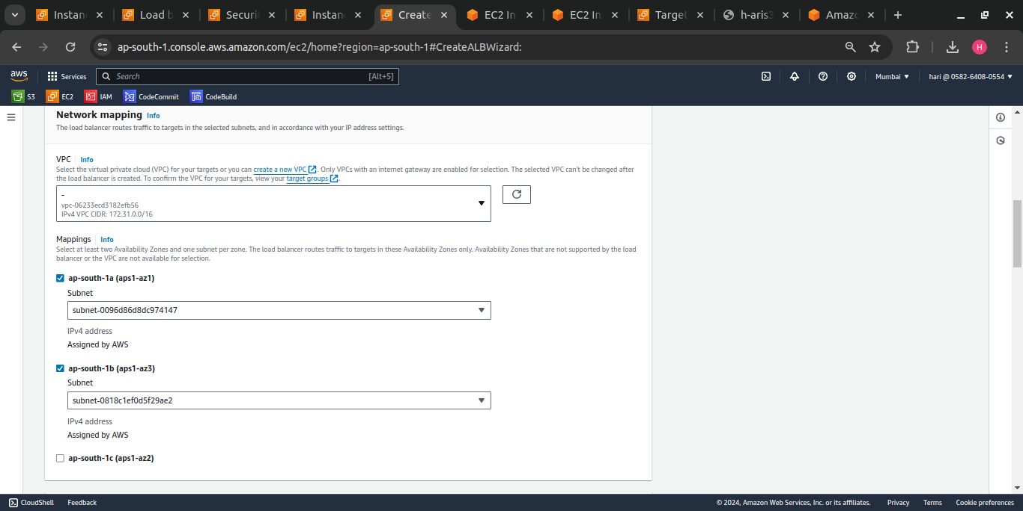

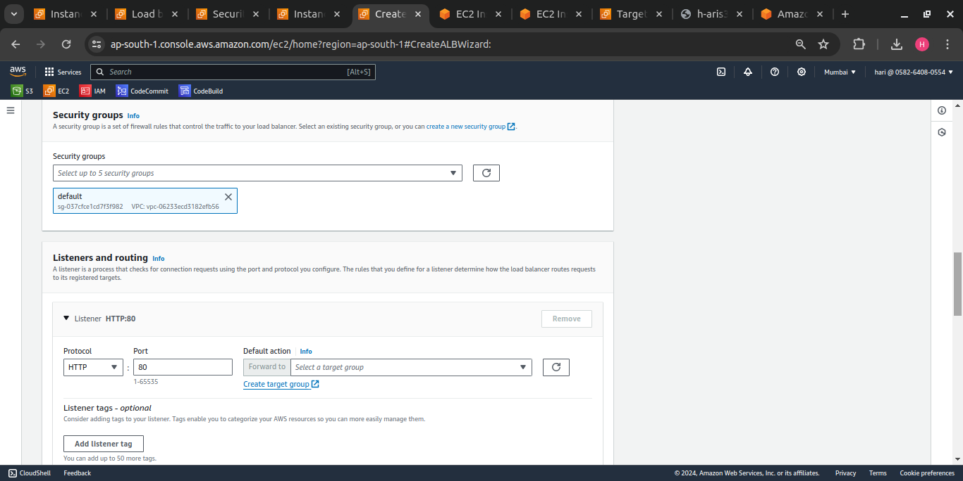

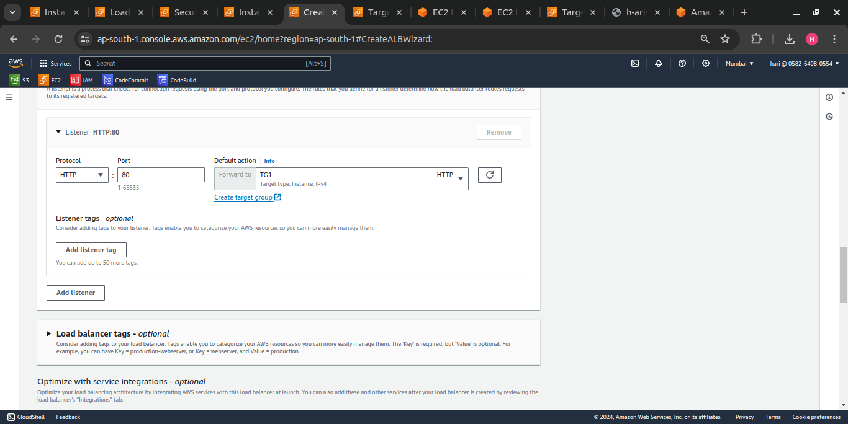

Creating Target group

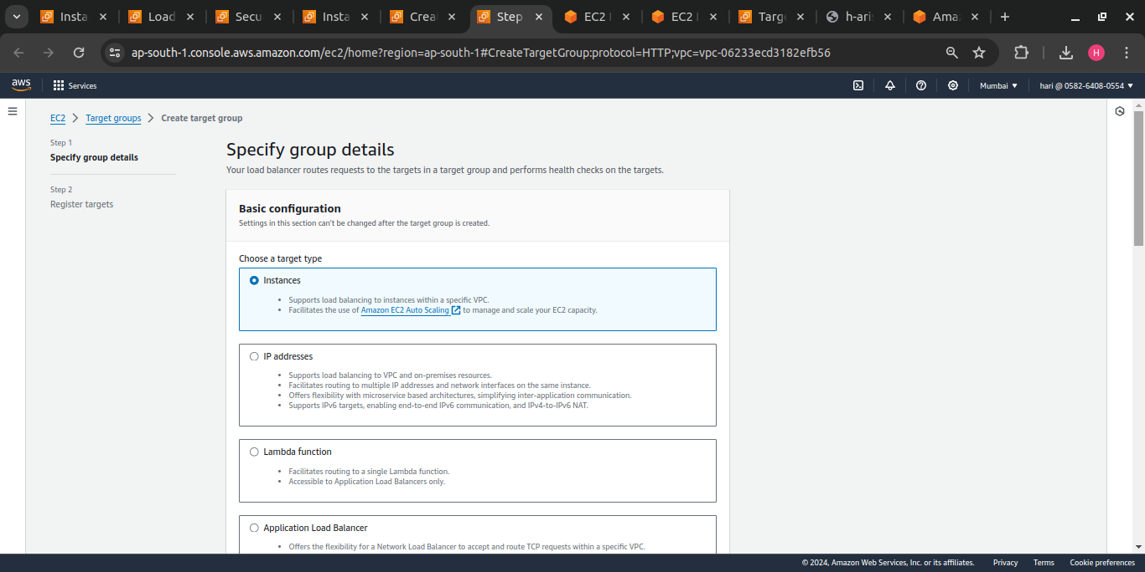

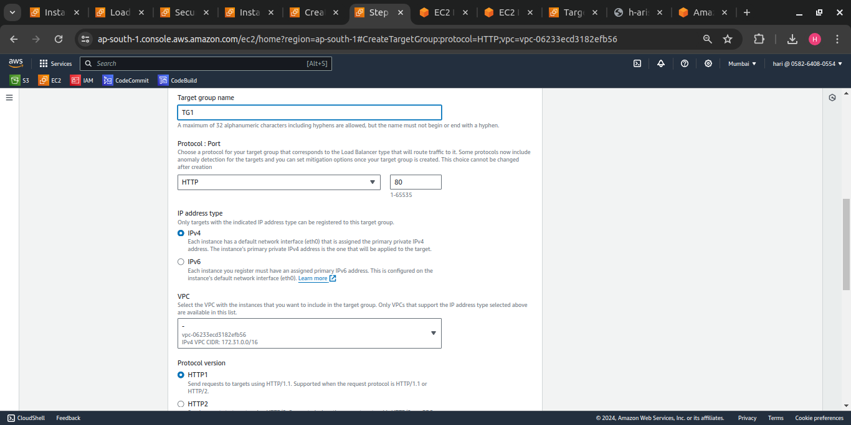

Registering targets with created 2 instances,

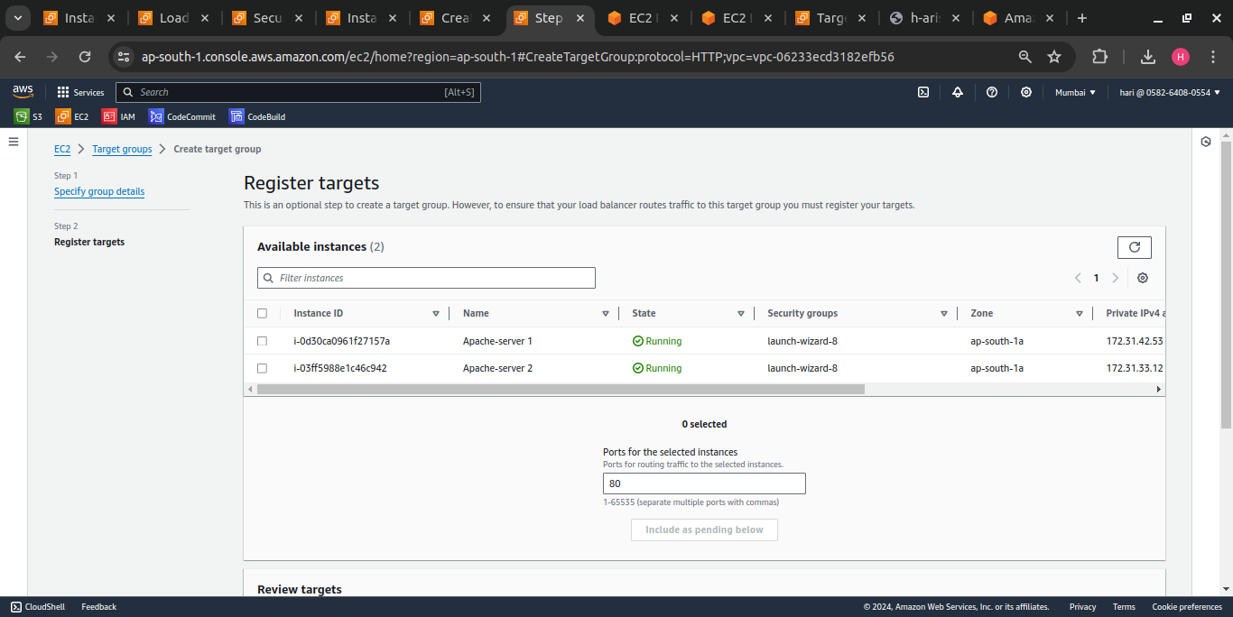

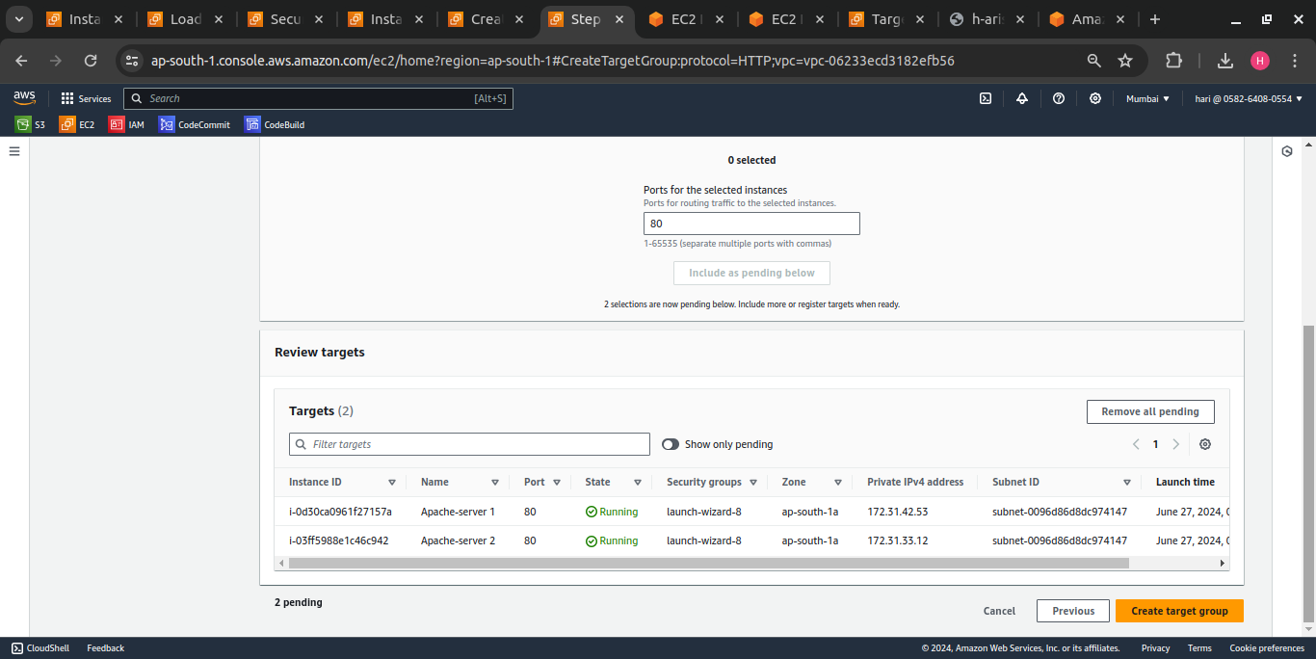

Target group Created,

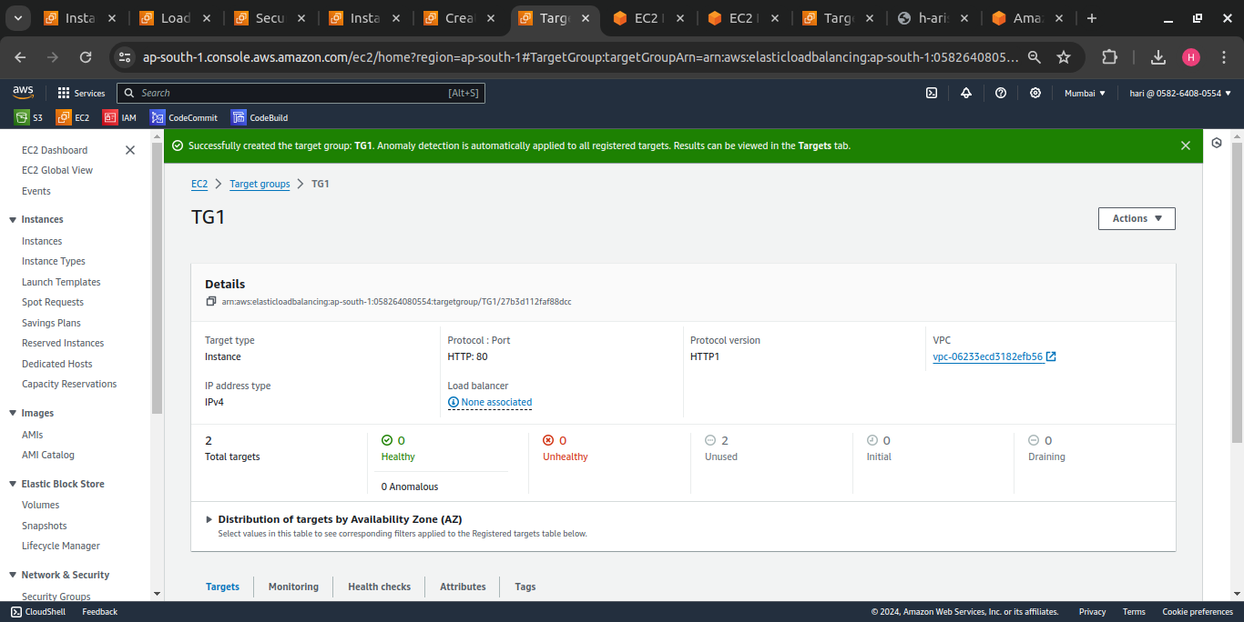

Instances are Healthy under registered targets ,

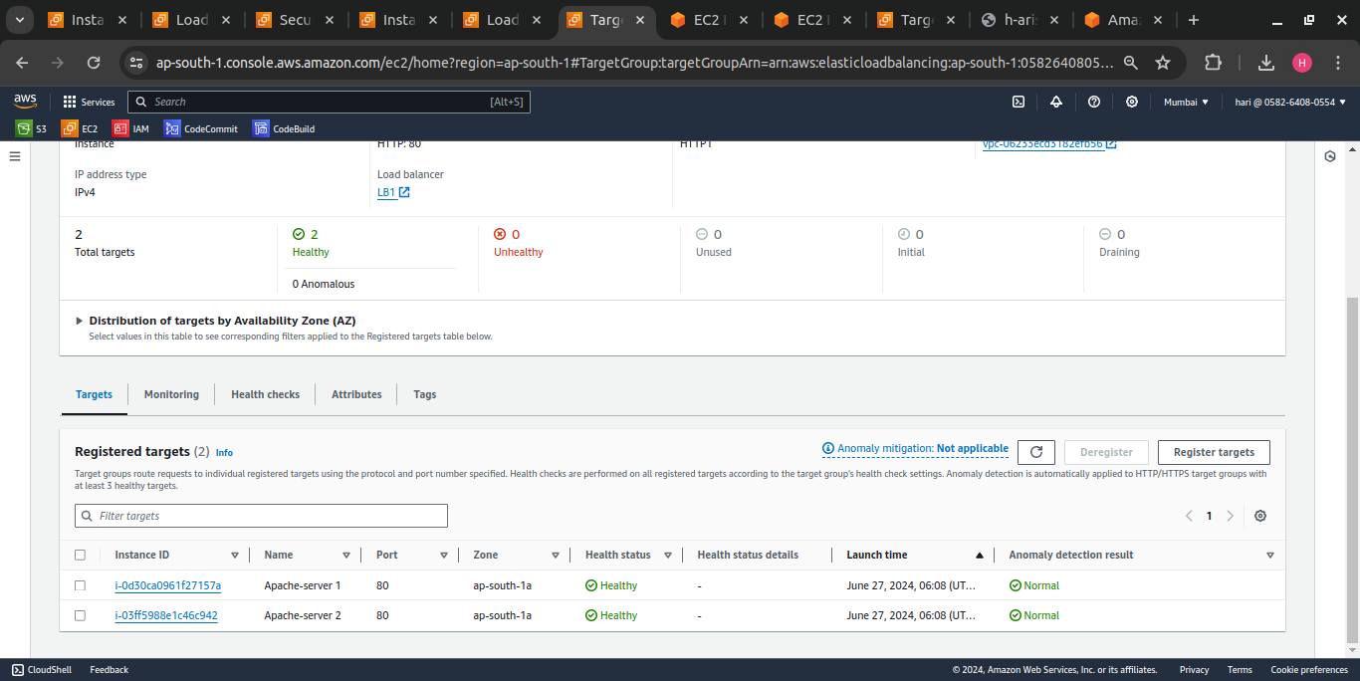

Load Balancer Created,

